**Capstone - Exercise 7: Deploy DevOps jar file using Jenkins**

**Step-1:**

Open the Cloud Platform Console at [https://console.cloud.google.com](https://console.cloud.google.com/).

Click on the three horizontal bars at the left most side of the blue bar near the top of the browser window. *Select Compute Engine*.

Select *VM Instances*. You should see the virtual machine you created earlier.

Click on the checkbox to the left of the VM name and then select *START*. It will take a few moments to start.

Click on *SSH* to start a terminal window.

**Change the host name to student:** Find the icon that looks like a gear in the upper right-hand corner of this terminal browser window and select *Change Linux User Name*. Enter *student* and *click Change*. Now, notice the prompt that says "student@lab:~$"

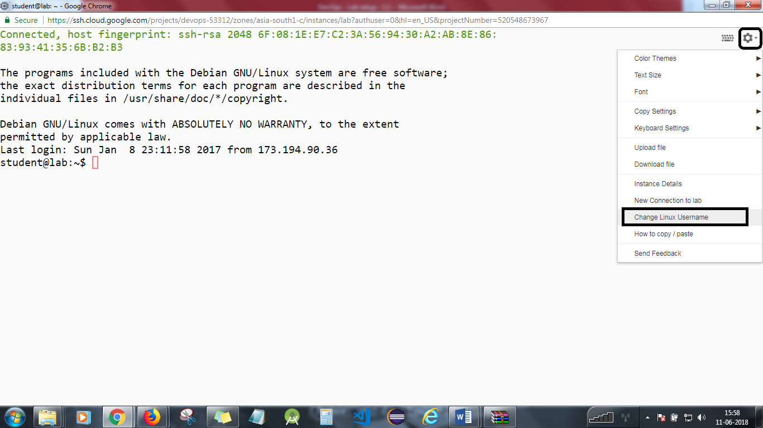

Install the Tomcat in your system. Follow the update steps and enter the commands:

*sudo su*

*apt-get update*

*apt-get upgrade*

*cd /opt*

go to the Apache tomcat server and copy the link address as shown below;

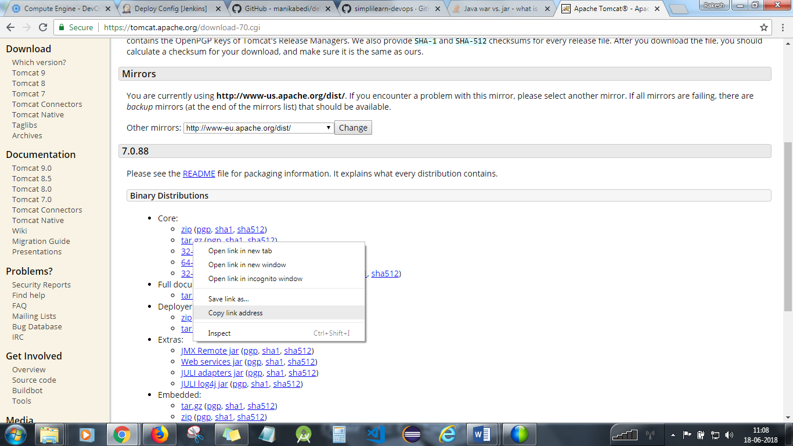

Now, type : *wget <the link address>* in the terminal.

Extract the file with: *tar –xvzf <filename>*

Type ls –l to confirm:



To confirm if you have installed the tomcat, do the following:

*cd*

*cd /opt*

*cd apache\**

*cd bin*

*./startup.sh*

Goto any browser and type: <External IP address of VM >:8080

Ctrl+D to exit from root.

**Step 2**

Select *create new jobs*.  
Enter the name *DeployDevOps*.  
Select *Freestyle project*.  
Hit *OK*.

**Step 3**

Under Source Code Management, select Git and paste your Git repository URL. It can be your local Git repository path also.

**Step 4**

Select *build steps*.  
Select *Top Level Maven Targets.*

Select Default Maven and in goals, enter *package.*

In Post Build Actions, select *Archive the Artifacts* under Files to archive, enter **/target/DevOpsProject.war

Apply and save.

**Step 5**

Select *create new jobs*.  
Enter the name *DeployToTomcat*.  
Select *Freestyle project*.  
Hit *OK*.

**Step 6**

Under Source Code Management, select Git and paste your Git repository URL. It can be your local Git repository path also.

Under Build Triggers, select Build after other projects are built and enter *DeployDevOps.*

**Step 7**

Go to Post Build Actions and select *Deploy war/ear file to your container*.

Under *war/ear files,* enter **/*.war

In context path, enter the name of your war file.

Make sure you have Tomcat 7 or above installed on your virtual machine. If Jenkins is listening on port 8080, make sure Tomcat is set up on another port. You can have Tomcat running on another server or VM. Make sure you have the IP address of the server.

**Step 8**

Under Containers, select Tomcat 7.x or whatever version of Tomcat you are using.

Enter Manager user name and password of your Tomcat.

Enter the URL of your Tomcat server.

Click Apply and Save.

**Step 9**

Click on the Jenkins project Build, and click on Build Now.

Click on last build history, and click on Console Output.

You will need to stop the lab computer at the end of each day to prevent it from accumulating costs during the evening and night.

From the Web UI, you can navigate to the Compute Engine section and select your lab computer. When it is selected, click on the icon representing the "Stop" operation as shown below:

